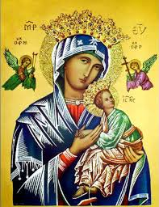
Our Lady of Perpetual Help Parish
14 Castledare Place, Wilson 6107. Telephone: 9258 6003
Email: Wilson@perthcatholic,org.au
Website: www.wilsoncatholicchurch.com
Parish Priest: Reverend Father Greg D’Almeida.
Email: gregory.dalmeida@perthcatholic.org.au
Presbytery Telephone: 9458 6586
Parish Council and Rosters: Lorraein O’Callaghan-Munt.
Mobile Number: 0417942854 Email: Munt.pandL8@bigpond.com
Parish Safeguarding Officers: Toto Olita and Rob Marshall
Parish Newsletter: Cliff Nunes. Email: cliffordgerard@bigpond.com
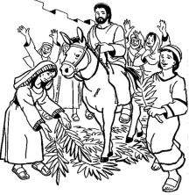
Passion of the Lord (Palm) Sunday. Year C. 10th April 2022

Gospel: Luke 22:14 – 23:56
This Sunday, called Passion (Palm) Sunday, is the first day of Holy Week. There are two Gospels proclaimed at today’s Mass. The first Gospel, proclaimed before the blessing/procession of palms, tells of Jesus’ triumphant entrance into Jerusalem. In following this custom of the blessing of palms, we are uniting ourselves with Christ’s journey to the Cross and Resurrection.

At the second Gospel (at the Liturgy of the Word) the events of Jesus’ passion are proclaimed in their entirety in Luke’s Gospel. We will hear these events proclaimed again during the Triduum, when we read the passion of Jesus from the Gospel of John.

Much of what is at the heart of our faith, is present in today’s gospel reading:

• The institution of the Eucharist at the Lord’s Supper: ‘This is my body which will be given for you; do this in memorial of me… This is the cup of the new covenant in my blood which will be poured out for you’.
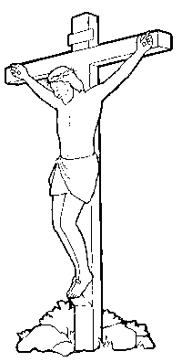
• The ministry of service and the priesthood: ‘I am among you as one who serves.’

• Peter’s denials: Like Peter, we so often fail, but we too can repent and begin anew.

• The Cross: The Cross reveals that God, in Jesus, entered into human suffering and death, and overcame the darkness. Jesus’ death on the Cross revealed for all time, that nothing can separate us from the love of God.

•The three statements that Jesus made from the Cross: His plea for forgiveness for those who have harmed Him, the invitation into paradise for the repentant thief, and the prayer of utter faith in God’s mercy, as He gives His spirit to God— forgiveness, repentance (and the reward of heaven), and faith in God’s mercy. (Adapted from the Melbourne Archdiocese Summit).

In Conclusion
Luke’s Gospel continues to emphasize the mercy and forgiveness of the Lord towards those who repent. Even on the cross, Jesus continues in this - He assures the repentant thief of his place in paradise. It is never too late - the Lord waits for each of us to bear “good fruit.”

HOLY WEEK BEGINS

Holy Week is a very sacred time of the year, for it is now that we will commemorate and remember the last week of Jesus' life on this earth. It is a time to clear our schedules of unnecessary activities. Our minds and hearts should be fixed on Jesus and what He did for us. Holy Week begins with Palm Sunday, which marks Jesus' triumphant entry into Jerusalem, followed by the Easter Triduum:

On Holy Thursday, we re-enact the Lord's Last Supper. On this day, priests all over the world are invited to renew their sacred vows. This is because, at the Last Supper, Jesus not only instituted the Eucharist but also the ministerial priesthood. When Jesus washed the feet of His disciples at the Last Supper, Jesus was setting an example of service and humility, for the priesthood.

On Good Friday, the day of the crucifixion and death of our Lord, we have the veneration of the Cross. A service is held at three o'clock in the afternoon (the hour Jesus is believed to have died). We go forward and kiss the Cross in order to show honour and respect for Christ's sacrifice for all of mankind.

Holy Saturday is a Vigil. We keep watch for the expectant rising of Our Saviour. This was the day Jesus went down into the netherworld - in the Apostles’ Creed we profess: “He descended into hell.” The Catechism of the Catholic Church (CCC) calls the descent "the last phase of Jesus' messianic mission," during which He opened heaven's gates, for the righteous who had gone before Him. Up to this time, the gates to heaven were closed because of the original sin of Adam and Eve. Jesus changed all that. By paying the price for our sins on the Cross, He gained for us our eternal salvation, and the gates of heaven were opened.

On Easter Sunday we celebrate the resurrection of Jesus from the dead. Jesus’ resurrection proves that those who trust in God will have eternal life. Jesus assured Martha at the tomb of Lazarus: “I am the Resurrection and the life; whoever believes in Me will live even though he dies and whoever lives and believes in me will never die.” (John 11: 25-26). This is why Easter Sunday (the Resurrection) is the greatest day ever, for the faithful. Jesus is truly the Son of God and everything He taught us, is the Truth.

After Jesus Died on the Cross – what happened next??
We know that Jesus died on the Cross and rose on the third day, but what happened in between? In the Apostles’ Creed we profess that Christ descended into hell. Jesus descended into hell as Saviour, proclaiming the Good News and to free all the righteous souls, who had died before Him and to take them to heaven.
The Catechism of the Catholic Church (CCC 631-637) offers clarity on this:
Scripture calls the abode of the dead Hell, or, Sheol in Hebrew, or, Hades in Greek. This was the place for all the dead who had died before Christ, whether evil or righteous, whilst they awaited Christ the Redeemer. This does not mean that all the dead in hell/sheol/hades are identical, as Jesus reveals through the parable of the poor man (Lazarus) and the rich man - when Lazarus died, he was received and comforted in “Abraham’s embrace” in Hades; whilst, when the rich man died, he was kept (separately) “in torment” in Hades (Luke 16: 22-26); both were in Hades but in different places! It is precisely these holy souls, in Abraham’s bosom, who awaited their Saviour, and to whom Christ delivered “the Good News,” when He descended into hell. Jesus did not descend into hell to deliver the damned but rather, to free the righteous who had gone before Him. Jesus’ descent into hell brings the Gospel message of salvation to complete fulfillment (and it is the last phase of Jesus’ messianic mission).
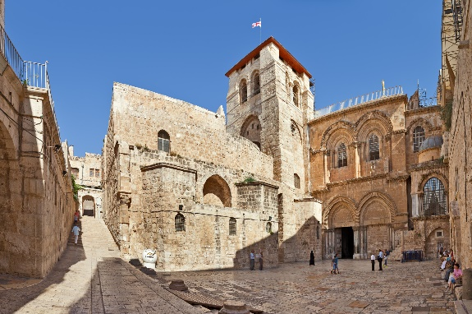
Remember Our Holy Land
The Good Friday Collection for the Holy Land is 15th April 2022. This annual collection supports the work of the Church in the Holy Land, assisting local Christians and others, with hospitals and healthcare, education, employment and orphanages. The collection also helps maintain 74 churches, holy sites and shrines associated with the life of Jesus.
Meanwhile, in the Holy Land, within the walls of the Church of the Holy Sepulchre in Jerusalem, is the spot where Jesus was crucified and died. Here, in a sepulchre under the dome of the church, is where He was buried, and on the third day, rose from the dead. This is the most holy place on earth for Christians.
Parish Lenten Program
The virtues of prayer, fasting and almsgiving are at the heart of our Lenten experience. Through prayer we are drawn closer to God so that we are better able to realise our baptismal promise to live as Jesus teaches us. Fasting joins us in solidarity with the poor who often have no choice but to live without food. Almsgiving is a sign of our commitment to others and our compassion. During Lent, we remember our vows to reject sin and to be disciples of Jesus.
DATE | EVENT & TIME (PC = Project Compassion)
10th April | PASSION/PALM Sunday. PC: 2022 Project Compassion donations are to be used to help ensure a better future for the needy.
14th April | HOLY THURSDAY 6.00 pm Washing of the Feet & Last Supper
15th April | GOOD FRIDAY Special collection for our Holy Land and Fasting  Stations of the Cross 10am  The Passion of Christ 3pm
16th April | HOLY SATURDAY 6.30pm  The Vigil and lighting the Easter Fire/Candle.
17th April | EASTER SUNDAY 9.30am

2022 Project Compassion Concludes
For over half a century, generations of Australians have participated in Project Compassion. The initiative began in 1965 – making it one of the nation’s longest running charity campaigns. Throughout five decades of natural disasters, conflicts and crises, Caritas Australia has worked alongside vulnerable communities with the generous support of Australians. During the pandemic, local partnerships have helped Caritas Australia to respond quickly to minimise the spread of the coronavirus. This year, Caritas Australia has presented five stories of Caritas Australia striving to provide a better future for the disabled, the poor and the vulnerable’ – just a few stories amongst the millions of people who have been helped through Project Compassion. Our financial support allows Caritas Australia to help the poor and the vulnerable, to move forward and to help themselves, their families and their communities.
Please deposit your Project Compassion envelopes in either collection box.

Our Parish Worship Schedule
A parish is a community of disciples of Jesus, who gather to celebrate the Mass and to “live the Gospel.” We are a community of Jesus’ disciples and our church is here for our collective and individual worship and prayers. We welcome the faithful to our Mass, or, to light a candle at our Marian chapel, or, to just pray in silence; and to grow spiritually.
Mass Times Mon, Tue, Wed, Thu & Fri 8.00 am (the Rosary after)
Saturday 6.00 pm
Mass Times Sunday 9.30 am
Reconciliation Saturday night 5.15 – 5.45 pm
Anointing of the Sick Liaise with Fr Greg
Baptisms, marriages and funerals Liaise with Fr Greg

Our Prayers of the Faithful
In our parish prayers of the faithful, we pray to the Lord, to help and comfort our sick and suffering. We also pray for the souls of our recently departed, as well as, for those whose anniversaries, we remember at Mass today.
Prayers for Our Sick and Suffering
Crowley family, Joe Sundaram, Thilak, Diana Scully, Bluey Thompson, Celeste Vicensoni, Michael D’Souza, Glen Langan, Carla, Annette, Joe Gibson, Georgina and Ronnie Ghosh, Gemma Altieri, Fred Kara, Reg Brown, Mary & Derrick Jansen, Marie Webster Viola, Gerry and Maisie Prendergast, James Rydqvist, Annie Magdalena Rydqvist, Anne Rydqvist, Dr Andrew Chilufya Snr, Robbie Iliffe, Claire Webster, Donna Green, Horatio Hill, Vernon Thompson, Ilean Wright, Elham Nejaty, Cathy and Peter Ghouse, Jimmy Olivero, Kaye McIntyre, Alvin Desker, Jess Cable, Jeff and Tony Francis, Fr Andre, Sheila Vanwieringan, CD Joseph, Marina Lim, Joseph Fernandes, Wendy Price, Julie Pinto, Christopher Jaffer, Yianni Donato, Bonnie Sullivan, Joslyn De Sylva and Philomena Rodrigues.
Prayers for our Recently Departed
Terry Hogben and Glyn Ashley.
“God blesses those people who grieve. They will find comfort.” (Matthew 5:4).
Anniversaries of our Beloved Deceased
Raymond la Granade (07 Apr), Lilian Nunis (07 Apr), Albert Wong (08 Apr), Margarida Gomes (09 Apr), Tommy Sheehan (09 Apr), Joe Wong (10 Apr), Cedric Kleinman (12 Apr) and all our departed relatives and friends.
Note: Parishioners may email Cliff at: cliffordgerard@bigpond.com, for any additions (or deletions) to our lists of sick, recently deceased and anniversaries, whom you wish to be included in our “Prayers of the Faithful.” Everyone has a name and if we are to pray for them - we should say their name.

