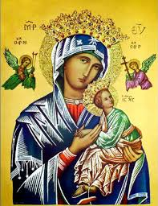
Our Lady of Perpetual Help Parish
14 Castledare Place, Wilson 6107. Telephone: 9258 6003
Email: Wilson@perthcatholic.org.au
Website: www.wilsoncatholicchurch.org
Parish Priest: Reverend Father Greg D’Almeida.
Email: gregory.dalmeida@perthcatholic.org.au
Presbytery Telephone: 9458 6586
Parish Council and Rosters: Lorraein O’Callaghan-Munt.
Mobile Number: 0417942854 Email: Munt.pandL8@bigpond.com
Parish Safeguarding Officers: Toto Olita and Rob Marshall
Parish Newsletter: Cliff Nunes. Email: cliffordgerard@bigpond.com
2nd Sunday of Easter (Divine Mercy Sunday). Year C. 24th April 2022

Gospel: John 20:19–31
In the evening of that same day, the first day of the week, the doors were closed in the room where the disciples were, for fear of the Jews. Jesus came and stood among them. He said to them, ‘Peace be with you’, and showed them his hands and his side. The disciples were filled with joy when they saw the Lord, and he said to them again, ‘Peace be with you. ‘As the Father sent me, so am I sending you.’ After saying this he breathed on them and said: ‘Receive the Holy Spirit. For those whose sins you forgive,
they are forgiven; for those whose sins you retain, they are retained.’
Thomas, called the Twin, who was one of the Twelve, was not with them when Jesus came. When the disciples said, ‘We have seen the Lord’, he answered, ‘Unless I see the holes that the nails made in his hands and can put my finger into the holes they made, and unless I can put my hand into his side, I refuse to believe.’ Eight days later the disciples were in the house again and Thomas was with them. The doors were closed, but Jesus came in and stood among them. ‘Peace be with you’ he said. Then he spoke to Thomas, ‘Put your finger here; look, here are my hands. Give me your hand; put it into my side. Doubt no longer but believe.’ Thomas replied, ‘My Lord and my God!’ Jesus said to him: ‘You believe because you can see me. Happy are those who have not seen and yet believe.’ There were many other signs that Jesus worked and the disciples saw, but they are not recorded in this book. These are recorded so that you may believe that Jesus is the Christ, the Son of God, and that believing this you may have life through his name.

In Summary
This gospel is one of transformation. The fear of the disciples, locked in their upper room and huddled in upon themselves, is transformed by the gift of peace that Jesus brings and his giving of the Spirit to strengthen them on their way. The doubt of Thomas is transformed by his encounter with the risen Lord. With this transformation, however, comes responsibility. Just as Jesus was sent by the Father, now, too, the disciples are sent into the world to act as Jesus did. (Melbourne Archdiocese Summit).
In Conclusion
This Gospel combines two scenes: Jesus’ appearance to His disciples after his Resurrection and Jesus’ dialogue with Thomas, eight days later. On each occasion Jesus greets His disciples with the gift and blessing of peace: ‘Peace be with you’

Jesus gifts the Holy Spirit to His disciples and commissions them to continue the work which He has begun. Jesus grants the means to accomplish this mission when He gives His disciples the gift of the Holy Spirit. Forgiveness and reconciliation are gifts to us from our Lord. The Church continues Jesus’ ministry of forgiveness and reconciliation through the mercy of God.
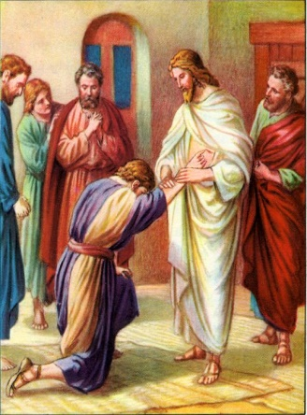
Thomas represents the reality of the Church. All but the first disciples of Jesus must believe without seeing. Like Thomas, we may doubt the news that Jesus, who was crucified and buried, appeared to His disciples. It is part of our human nature to seek hard evidence that the Jesus who appeared to the disciples after His death, is the resurrected Christ. Thomas is our representative who obtains this evidence. He gives witness to us that the Jesus who was raised is the same Jesus who had died. Through the gift of the Holy Spirit, we are among those who are blessed, for we “have not seen and yet believe.” We are disciples of Jesus.

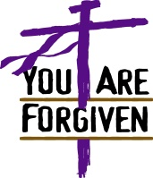
This Gospel and the Sacrament of Reconciliation
‘For those whose sins you forgive, they are forgiven; for those whose sins you retain, they are retained.’ Jesus’ power to forgive sins is conferred on the Church. Through baptism, God’s forgiveness becomes available to us, but human beings do not lose their tendency to sin simply because we are baptised. The sacrament of reconciliation is there to assist the faithful to acknowledge human sinfulness and seek forgiveness and reconciliation with God. God is merciful and forgiving, when we repent.


We are Invited to Use the Same Greeting as Jesus at Mass
Jesus did not want His disciples to be afraid, so, His first words/greeting, after His resurrection, to them was: “Peace be with you.” Jesus wanted the disciples to be unafraid and to trust Him. At Mass, we are invited to offer this same greeting to others: “Peace be with you.” It is our greeting of peace and trust in Jesus. We are disciples of Jesus.

The Second Sunday of Easter is Celebrated as Divine Mercy Sunday

In the Jubilee Year 2000, Pope John Paul II proclaimed that from that year forward, the Second Sunday of Easter would be celebrated as Divine Mercy Sunday. This was proclaimed at the Canonization Mass of St Faustina Kowalska, who worked throughout her life to make all aware of the merciful love of God. In her years in the convent, St Faustina heard a call from God to make God’s mercy known to the world, so that the world may more fully receive God’s healing grace. When celebrating Divine Mercy Sunday, the faithful are called to reflect more personally on the graces won through the life, death, and Resurrection of Jesus Christ. In this way their hearts may be more fully aware of the mercy of God for them personally, and for all the world – God is merciful and forgiving, if we repent.
Jesus said to St Faustina: "I am sending you with My mercy to the people of the whole world. I do not want to punish mankind, but I desire to heal it, pressing it to My merciful Heart."

The Chaplet of Divine Mercy
Our Lord gave St Faustina a set of prayers to invoke His mercy, called the Chaplet of Divine Mercy. On standard rosary beads, we pray the following prayers:

First, on the crucifix, one Our Father, one Hail Mary and the Apostles’ Creed. On each Our Father bead on our rosary we pray: “Eternal Father, I offer You the most precious Body, Blood, Soul, and Divinity of Your dearly beloved Son, Our Lord Jesus Christ, in atonement for our sins, and those of the whole world.” On each Hail Mary bead we pray: “For the sake of His sorrowful passion, have mercy on us, and on the whole world.” Repeat for the five decades. To conclude, pray three times: “Holy God, holy mighty One, holy immortal One, have mercy on us and on the whole world.”

Our Parish Worship Schedule
A parish is a community of disciples of Jesus, who gather to celebrate the Mass and to “live the Gospel.” We are a community of Jesus’ disciples and our church is here for our collective and individual worship and prayers. We welcome the faithful to our Mass, or, to light a candle at our Marian chapel, or, to just pray in silence; and to grow spiritually.
Mass Times Mon, Tue, Wed, Thu & Fri 8.00 am (the Rosary after)
Saturday 6.00 pm
Mass Times Sunday 9.30 am
Reconciliation Saturday night 5.15 – 5.45 pm
Anointing of the Sick Liaise with Fr Greg
Baptisms, marriages and funerals Liaise with Fr Greg

Our Prayers of the Faithful
In our parish prayers of the faithful, we pray to the Lord, to help and comfort our sick and suffering. We also pray for the souls of our recently departed, as well as, for those whose anniversaries, we remember at Mass today.
Prayers for Our Sick and Suffering
Crowley family, Joe Sundaram, Thilak, Diana Scully, Bluey Thompson, Celeste Vicensoni, Michael D’Souza, Glen Langan, Carla, Annette, Joe Gibson, Georgina and Ronnie Ghosh, Gemma Altieri, Fred Kara, Reg Brown, Mary & Derrick Jansen, Marie Webster Viola, Gerry and Maisie Prendergast, James Rydqvist, Annie Magdalena Rydqvist, Anne Rydqvist, Dr Andrew Chilufya Snr, Robbie Iliffe, Claire Webster, Donna Green, Horatio Hill, Vernon Thompson, Ilean Wright, Elham Nejaty, Cathy and Peter Ghouse, Jimmy Olivero, Kaye McIntyre, Alvin Desker, Jess Cable, Jeff and Tony Francis, Fr Andre, Sheila Vanwieringan, CD Joseph, Marina Lim, Joseph Fernandes, Wendy Price, Julie Pinto, Christopher Jaffer, Yianni Donato, Bonnie Sullivan, Joslyn De Sylva and Philomena Rodrigues.

Prayers for our Recently Departed
Terry Hogben and Glyn Ashley.

Anniversaries of our Beloved Deceased
Gael Ee (21 Apr), Felix Polancos (22 Apr), Sonya Miller (23 Apr), Paul Mento (25 Apr), Fred Hughes (25 Apr) and all our departed relatives and friends.

Note: Parishioners may email Cliff at: cliffordgerard@bigpond.com, for any additions (or deletions) to our lists of sick, recently deceased and anniversaries, whom you wish to be included in our “Prayers of the Faithful.” Everyone has a name and if we are to pray for them - we should say their name.

Our Next Parish St Vincent de Paul Food Donations is to be 07th/08th May 2022
For parishioners who may wish to contribute to this worthy program, any non-perishable food in tins, packets or boxes will do (but no glass please). In addition to a food hamper, a $30 Woolworths voucher is usually provided to enable the purchase of essentials like; fresh fruit and vegetables, baby food and more. Cash donations may be deposited in our SVDP/poor donation box at the entrance of the church, to enable the purchase of cash vouchers.
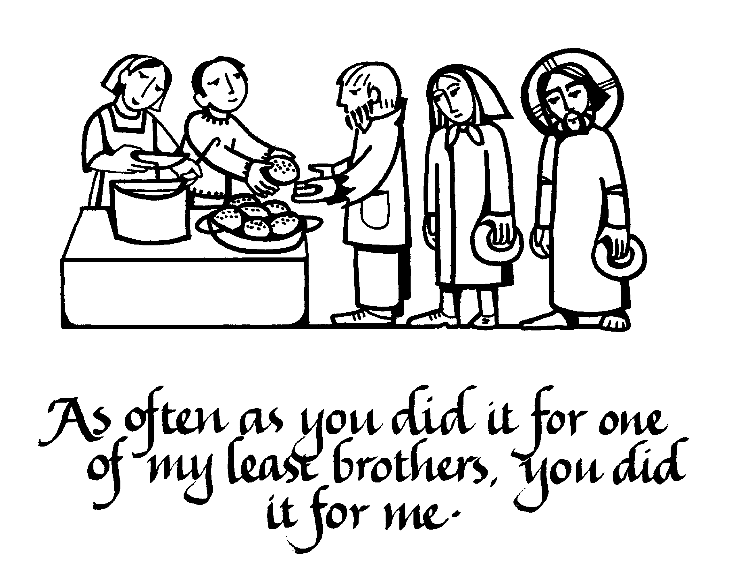
The King will reply, 'Truly I tell you, whatever you did for one of the least of these brothers and sisters of mine, you did for me.' "Then he will say to those on his left, 'Depart from me, you who are cursed, into the eternal fire prepared for the devil and his angels. For I was hungry and you gave me nothing to eat, I was thirsty and you gave me nothing to drink, I was a stranger and you did not invite me in, I needed clothes and you did not clothe me, I was sick and in prison and you did not look after me.” They also will answer, 'Lord, when did we see you hungry or thirsty or a stranger or needing clothes or sick or in prison, and did not help you?" He will reply, 'Truly I tell you, whatever you did not do for one of the least of these, you did not do for me.' (Matthew 25: 40-45).

Parishioners who may need a “helping hand,” may contact the SVDP Society for assistance, or speak with our local SVDP representatives: Bruno George (mobile: 0470571041) at Wilson Parish, or Sister Charla (telephone: 93545083) at Riverton Parish. The names of those requesting and receiving assistance is always confidential. Food donations may be left at the rear of the church, or at our parish centre.
ANZAC Day is Monday 25th April

"They shall grow not old, as we that are left grow old;
Age shall not weary them, nor the years condemn.
At the going down of the sun and in the morning
We will remember them."

