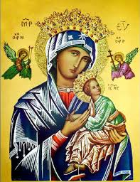
Our Lady of Perpetual Help Parish
14 Castledare Place, Wilson 6107. Telephone: 9258 6003
Email: Wilson@perthcatholic.org.au
Website: www.wilsoncatholicchurch.org
Parish Priest: Reverend Father Greg D’Almeida.
Email: gregory.dalmeida@perthcatholic.org.au
Presbytery Telephone: 9458 6586
Parish Council and Rosters: Lorraein O’Callaghan-Munt.
Mobile Number: 0417942854 Email: Munt.pandL8@bigpond.com
Parish Safeguarding Officers: Toto Olita and Rob Marshall
Parish Newsletter: Cliff Nunes. Email: cliffordgerard@bigpond.com
4th Sunday of Easter. Year C. 08th May 2022
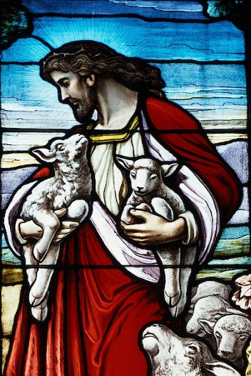
Gospel: John 10:27–30
Jesus said:
‘The sheep that belong to me listen to my voice;
I know them and they follow me.
I give them eternal life;
they will never be lost and no one will ever steal them from me.
The Father who gave them to me is greater than
anyone, and no one can steal from the Father.
The Father and I are one.’

In Summary
This text in John’s Gospel is set in Jerusalem, while Jesus is there for the Feast of Dedication (John 10:22), a feast celebrating the presence of God in the temple. The temple was not just a building for Israel. It was the visible place where God dwelt in the heart of God’s people; to go to the temple and worship was to ‘approach God’. Jesus is teaching something completely new here. He stands within the temple precinct and declares that it is only through him and through hearing his voice that people can come to the Father. The voice of Jesus is both seen and heard in the events of his life, death and resurrection. It is through all these events that the ways of God are made known to us.

The care that a shepherd showed for his flock remains a powerful image in the Church, despite its origins in an ancient agricultural society. In our country, with its vast paddocks and endless fences, the work of a true shepherd has lost some of its meaning, but the intimacy and tenderness of the image still speak to us of the closeness of Christ’s relationship with all who believe in him.
(The summary is from the Melbourne Archdiocese Summit)
In Conclusion
The fourth Sunday of Easter is also called Good Shepherd Sunday. The image of Jesus as the Good Shepherd and the faithful as His flock, has endured through the ages. The good shepherd provides protection and security for his flock, and cares for all his sheep.

Today's Gospel describes the relationship between Jesus and us (the sheep in His flock):
- We listen to His Word.
- We understand His Word.
- We practice the teachings of His Word (we live a “gospel life”).

Jesus promises to those of us who listen to His Word and live a “gospel life:”
- He will give us eternal life.
- He will not abandon us (we will never “be lost”, nor, “stolen”).

Jesus also identifies with the Father and He tells us that they are one –
to know Jesus is to know the Father.
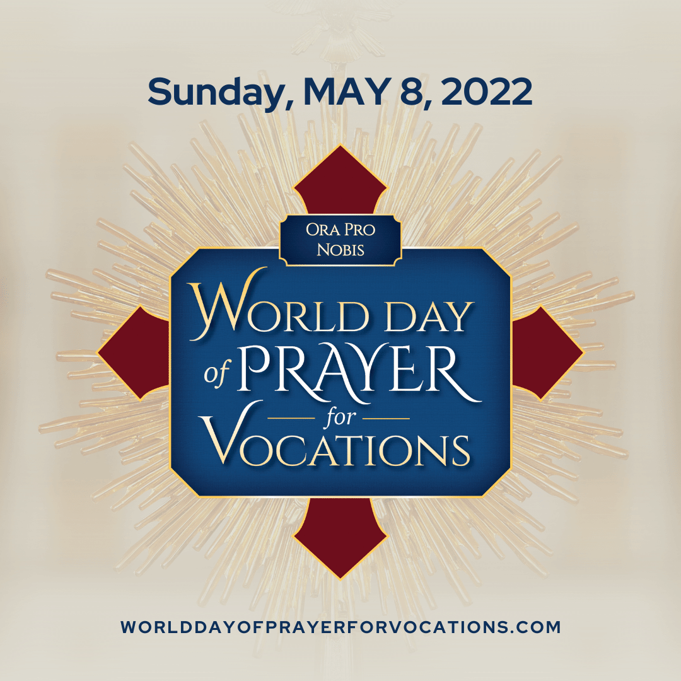
World Day of Prayer for Vocations
Today the Church throughout the world prays for vocations. As Catholics, we firmly believe that God has a plan for each of us. God calls some to marriage, some to the priesthood and religious life, and others to live as generous single people. There is no one among us who does not have a divine vocation!

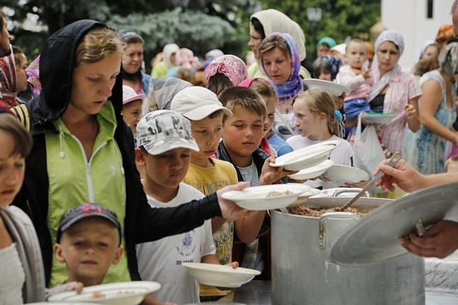
Ukraine Emergency Collection Next Weekend (14th /15th May 2022)
Catholic Mission, is responding to an urgent call for help from its mission partners in Poland and Romania, who are desperately trying to comfort and support refugees fleeing across the border from Ukraine. In Romania and Poland, individual parishioners and parishes, are providing emergency relief and pastoral support, to thousands of women, children and the elderly, amid this terrible crisis.
Our generous support will help the elderly, and the women and children, seeking safety and shelter in Poland and Romania. Please use the envelopes provided and leave your donation in either collection next week, or, donate online at: www.catholicmission.org.au/ukraine
Our Parish Worship Schedule
A parish is a community of disciples of Jesus, who gather to celebrate the Mass and to “live the Gospel.” We are a community of Jesus’ disciples and our church is here for our collective and individual worship and prayers. We welcome the faithful to our Mass, or, to light a candle at our Marian chapel, or, to just pray in silence; and to grow spiritually.
Mass Times Mon, Tue, Wed, Thu & Fri 8.00 am (the Rosary after)
Saturday 6.00 pm
Mass Times Sunday 9.30 am
Reconciliation Saturday night 5.15 – 5.45 pm
Anointing of the Sick Liaise with Fr Greg
Baptisms, marriages and funerals Liaise with Fr Greg

Our Prayers of the Faithful
In our parish prayers of the faithful, we pray to the Lord, to help and comfort our sick and suffering. We also pray for the souls of our recently departed, as well as, for those whose anniversaries, we remember at Mass today.
Prayers for Our Sick and Suffering
Celia, Crowley family, Joe Sundaram, Thilak, Diana Scully, Bluey Thompson, Celeste Vicensoni, Michael D’Souza, Glen Langan, Carla, Annette, Joe Gibson, Georgina and Ronnie Ghosh, Gemma Altieri, Fred Kara, Reg Brown, Mary & Derrick Jansen, Marie Webster Viola, Gerry and Maisie Prendergast, James Rydqvist, Annie Magdalena Rydqvist, Anne Rydqvist, Dr Andrew Chilufya Snr, Robbie Iliffe, Claire Webster, Donna Green, Horatio Hill, Vernon Thompson, Ilean Wright, Elham Nejaty, Cathy and Peter Ghouse, Jimmy Olivero, Kaye McIntyre, Alvin Desker, Jess Cable, Jeff and Tony Francis, Fr Andre, Sheila Vanwieringan, CD Joseph, Marina Lim, Joseph Fernandes, Wendy Price, Julie Pinto, Christopher Jaffer, Yianni Donato, Bonnie Sullivan, Joslyn De Sylva and Philomena Rodrigues.
Prayers for our Recently Departed
Kunjachan Kalloor.
Anniversaries of our Beloved Deceased
Malcolm Boswell (05 May), Mary Castelino (05 May), Kitty Lynch (07 May), Nellie Pillay (08 May), Juliet Lobo (09 May), Mary De Costa (11 May) and all our departed relatives and friends.

Note: Parishioners may email Cliff at: cliffordgerard@bigpond.com, for any additions (or deletions) to our lists of sick, recently deceased and anniversaries, whom you wish to be included in our “Prayers of the Faithful.” Everyone has a name and if we are to pray for them - we should say their name.
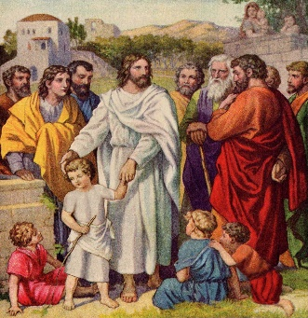
We Welcome “God’s Little Children” to Our Mass
People were bringing little children to Jesus to have him touch them, but the disciples rebuked them. When Jesus saw this, he was indignant. He said to them, “Let the little children come to me, and do not hinder them, for the kingdom of God belongs to such as these.” Mark 10: 13-14.
Note: Activity sheets and colour pencils, are available at the rear of the church, to occupy the children during Mass. Parents may even pin their child’s work on the noticeboard (when space is available) for others to appreciate their efforts.
Today is Our Parish St Vincent de Paul Donations

Food donations may be left at the rear of the church, or at our parish centre. Cash donations may be deposited in the “Poor Box” at the entrance to the church.
Parishioners who may need a “helping hand,” may contact the SVDP Society for assistance, or speak with our local SVDP representatives: Bruno George (mobile: 0470571041) at Wilson Parish, or Sister Charla (telephone: 93545083) at Riverton Parish. The names of those requesting and receiving assistance is always confidential.

Happy Mothers’ Day!!!
When Mary said “yes” to bringing Jesus into the world, she (like all mothers) took on both the joys and the pains, that came with motherhood.
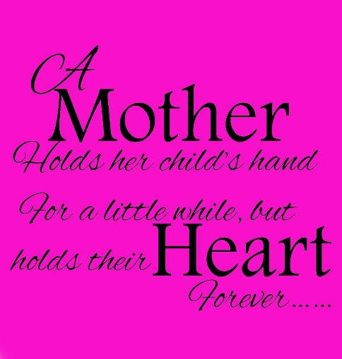
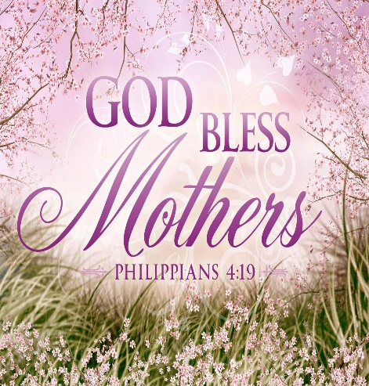

Friday 13th May is the Anniversary of Fatima
The Blessed Virgin Mary appeared six times to three shepherd children near the town of Fatima, Portugal, between 13th May and 13th October 1917. Appearing to the children, the Blessed Virgin told them that she had been sent by God with a message. Our Lady promised that Heaven would grant peace to all the world, if Her requests for prayer and consecration were heard and obeyed. In all Her appearances at Fatima, the Blessed Mother repeatedly emphasized the necessity of praying the Rosary daily and of performing acts of reparation and sacrifice. The heart of Our Lady's Message to the world is contained in what has come to be called the "Secret," which she confided to the three child seers in July 1917. The Secret actually consists of three parts. The first part of the Secret was a horrifying Vision of hell "where the souls of poor sinners go" and contained a plea from Our Lady for acts of prayer and sacrifice to save souls. The second part of the Secret prophesied war, however, it also contained Our Lady’s request for the Consecration of Russia to Her Immaculate Heart, as a condition for peace: “I want you to come here on the thirteenth of next month, to continue to pray the Rosary every day in honour of Our Lady of the Rosary, in order to obtain peace for the world and the end to the war.” We can all pray a daily Rosary for our beloved departed, as well as, for peace in our time. Rosary cards are available at our Marian shrine.

