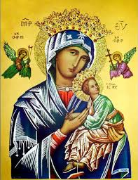
Our Lady of Perpetual Help Parish
14 Castledare Place, Wilson 6107. Telephone: 9258 6003
Email: Wilson@perthcatholic.org.au
Website: www.wilsoncatholicchurch.org
Parish Priest: Reverend Father Greg D’Almeida.
Email: gregory.dalmeida@perthcatholic.org.au
Presbytery Telephone: 9458 6586
Parish Council and Rosters: Lorraein O’Callaghan-Munt.
Mobile Number: 0417942854 Email: Munt.pandL8@bigpond.com
Parish Safeguarding Officers: Toto Olita and Rob Marshall
Parish Newsletter: Cliff Nunes. Email: cliffordgerard@bigpond.com
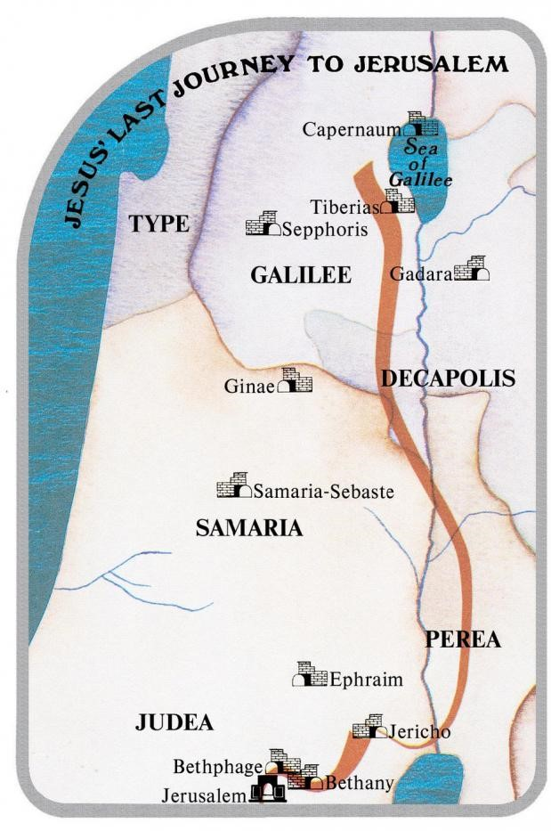
13th Sunday in Ordinary Time. Year C. 26th June 2022

Gospel: Luke 9: 51-62
As the time drew near for him to be taken up to heaven, Jesus resolutely took the road for Jerusalem and sent messengers ahead of him. These set out, and they went into a Samaritan village to make preparations for him, but the people would not receive him because he was making for Jerusalem. Seeing this, the disciples James and John said, ‘Lord, do you want us to call down fire from heaven to burn them up?’ But he turned and rebuked them, and they went off to another village. As they travelled along they met a man on the road who said to him, ‘I will follow you wherever you go.’ Jesus answered, ‘Foxes have holes and the birds of the air have nests, but the Son of Man has nowhere to lay his head.’ Another to whom he said, ‘Follow me’, replied, ‘Let me go and bury my father first.’ But he answered, ‘Leave the dead to bury their dead; your duty is to go and spread the news of the kingdom of God.’ Another said, ‘I will follow you, sir, but first let me go and say goodbye to my people at home.’ Jesus said to him, ‘Once the hand is laid on the plough, no one who looks back is fit for the kingdom of God.’

In Summary
This gospel text marks a turning point in Luke’s story of Jesus. He has made a momentous decision. When He is rejected by the very first village He approaches, the disciples want to punish them. But Jesus refuses violence and coercion as a means of conversion. He wants willing disciples! The following three brief exchanges outline what is needed for discipleship: it won’t necessarily be comfortable; there is a sense of urgency, and it requires single-mindedness and sometimes difficult choices. Comfort or family relationships cannot take priority over the kingdom of God, and once one becomes a follower of Christ, there can be no turning back. This gospel is not only about Jesus; it is about all those who seek to follow the road God has laid out for them. (Ref: Melbourne Archdiocese Summit – Exploring the Word).

Background on the Gospel Reading
In the gospel readings during Lent, we read that as Jesus’ journey brings Him closer to Jerusalem, He endeavours to explain and prepare His disciples for what awaits Him in Jerusalem. In today’s Gospel, Jesus is beginning His journey from Galilee to Jerusalem, which will end with His Death, Resurrection, and after 40 days - His Ascension.

Jesus may seem harsh here but He is already preparing His disciples for their trails and sacrifices, when they (in their apostolic mission) will take the Word of God to the world. In today’s gospel, Jesus highlights the demands and sacrifices which will be required of His disciples, on their apostolic mission:

- The disciples will be rejected in some places on their apostolic mission – here Jesus demonstrates that they should not be angry but to move on to the next place.
- The rest of today's reading is about the enormous personal demands which will be required of Jesus’ disciples/apostles: their safety and personal care will be lacking (even animals in the wild will have more security); their care for dead loved ones will not be possible (Leave the dead to bury their dead; your duty is to go and spread the news of the kingdom of God); and even the care of their family, cannot come before the demands of their apostolic mission - the demands of proclaiming the Kingdom of God takes precedence because once you begin to the plough, you cannot look back, or, the furrow will be crooked.
- Jesus wants the disciples to know the demands that will be required of them after His Death, Resurrection and Ascension; and after Pentecost, when they will begin their apostolic mission to evangelize and to baptise in the name of the Father, the Son and the Holy Spirit (as Jesus said to Peter - feed my lambs).
- Christian tradition records that all the apostles (except for John) will have violent deaths.

Wednesday 29th June is the Feast Day of the Apostles St Peter and St Paul
The Church celebrates the feast day of Saints Peter and Paul on 29th June. As early as the year 258, there is evidence of this Christian tradition, of celebrating the solemnities of both Saint Peter and Saint Paul on the same day. Together, these two saints are the founders of the See of Rome, through their preaching, ministry and martyrdom there.

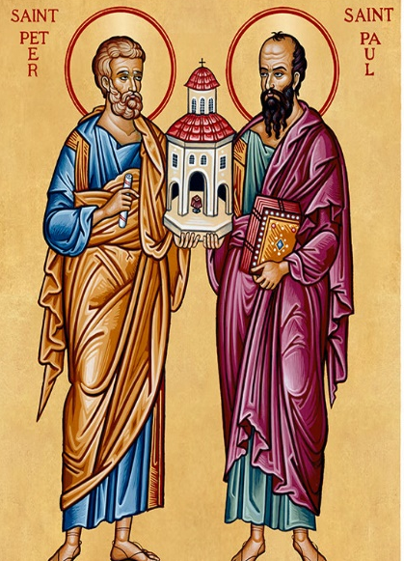
Jesus gave Peter the name Cephas, which means ‘Rock,’ because he was to become the rock upon which Christ would build His Church. Peter was a bold follower of the Lord. He was the first to recognize that Jesus was “the Messiah, the Son of the living God,” and eagerly pledged his fidelity until death. In his boldness, he also made mistakes, such as losing faith when walking on water with Christ and betraying the Lord on the night of His passion. Yet despite his human weaknesses, Peter was chosen to shepherd God's flock – Jesus’ final instruction to Peter before His Ascension was: “feed my lambs…tend my sheep…..feed my sheep.” The Acts of the Apostles record his role as head of the Church, after the Resurrection and Ascension of Christ. St Peter led the Apostles as the first Pope and ensured that the disciples kept the true faith. He spent his last years in Rome, leading the Church through persecution and eventually being martyred in the year 64. He was crucified upside-down at his own request, because he claimed he was not worthy to die as his Lord. He was buried on Vatican hill, and St Peter's Basilica is built over his tomb..

St Paul was the Apostle of the Gentiles. His letters are included in the writings of the New Testament, and through them we learn much about his life and the faith of the early Church. Before receiving the name Paul, he was Saul, a Jewish pharisee who zealously persecuted Christians in Jerusalem. Scripture records that Saul was present at the martyrdom of St Stephen. Saul's epiphany took place as he was on his way to Damascus to persecute the Christian community there. As he was traveling along the road, he was suddenly surrounded by a great light from heaven. He was blinded and fell off his horse. He then heard a voice saying to him, “Saul, Saul, why do you persecute me?” He answered: “Who are you, Lord?” Christ said: “I am Jesus, whom you are persecuting.” Though blinded, Saul continued to Damascus, where he was baptized and his sight was restored. He took the name Paul and spent the remainder of his life preaching the Gospel tirelessly to the gentiles. Paul was imprisoned and taken to Rome, where he was beheaded in the year 67. He is buried in Rome in the Basilica of St Paul Outside the Walls.

In a sermon in the year 395, St Augustine of Hippo said of Saints Peter and Paul: “Both apostles share the same feast day, for these two were one; and even though they suffered on different days, they were as one. Peter went first, and Paul followed. And so we celebrate this day made holy for us by the apostles' blood. Let us embrace what they believed, their life, their labours, their sufferings, their preaching, and their confession of faith.”

Our Parish Worship Schedule
A parish is a community of disciples of Jesus, who gather to celebrate the Mass and to “live the Gospel.” We are a community of Jesus’ disciples and our church is here for our collective and individual worship and prayers. We welcome the faithful to our Mass, or, to light a candle at our Marian chapel, or, to just pray in silence; and to grow spiritually.

Mass Times Mon, Tue, Wed, Thu & Fri 8.00 am (the Rosary after)
Saturday 6.00 pm
Mass Times Sunday 9.30 am
Reconciliation Saturday night 5.15 – 5.45 pm
Anointing of the Sick Liaise with Fr Greg
Baptisms, marriages and funerals Liaise with Fr Greg

Our Prayers of the Faithful
In our parish prayers of the faithful, we pray to the Lord, to help and comfort our sick and suffering. We also pray for the souls of our recently departed, as well as, for those whose anniversaries, we remember at Mass today.

Prayers for Our Sick and Suffering
Maria Marshall, Claire Webster, Ivan Fletcher, Fabian Edmunds, Celia, Crowley family, Joe Sundaram, Thilak, Diana Scully, Bluey Thompson, Celeste Vicensoni, Michael D’Souza, Carla, Annette, Joe Gibson, Georgina and Ronnie Ghosh, Gemma Altieri, Fred Kara, Reg Brown, Mary & Derrick Jansen, Marie Webster Viola, Gerry and Maisie Prendergast, James Rydqvist, Annie Magdalena Rydqvist, Anne Rydqvist, Dr Andrew Chilufya Snr, Robbie Iliffe, Donna Green, Horatio Hill, Ilean Wright, Elham Nejaty, Cathy and Peter Ghouse, Jimmy Olivero, Kaye McIntyre, Alvin Desker, Jess Cable, Jeff and Tony Francis, Fr Andre, Sheila Vanwieringan, CD Joseph, Marina Lim, Joseph Fernandes, Wendy Price, Julie Pinto, Christopher Jaffer, Yianni Donato, Bonnie Sullivan, Joslyn De Sylva and Philomena Rodrigues.
Prayers for our Recently Departed
John Cova, Phyllis Falk, Gopi Panickar, Sandra Young, Matthew Antony, Annamma Antony and Vernon Thompson.
Anniversaries of our Beloved Departed
Ian Cameron (23 Jun), Sharon Fletcher (23 Jun), Malcolm Taylor (23 Jun), Lilian Nunis (28 Jun) and all our departed relatives and friends.

Note: Parishioners may email Cliff at: cliffordgerard@bigpond.com, for any additions (or deletions) to our lists of sick, recently deceased and anniversaries, whom you wish to be included in our “Prayers of the Faithful.” Thank-you.
Everyone has a name, and if we are to pray for them, we should say their name.

Next Weekend is Our Parish St Vincent de Paul Donations
For parishioners who may wish to contribute to this worthy program, any non-perishable food in tins, packets or boxes will do (but no glass please). In addition to a food hamper, a $30 Woolworths voucher is usually provided to enable the purchase of essentials like; fresh fruit and vegetables, baby food and more. Cash donations may be deposited in our SVDP/poor donation box at the entrance of the church, to enable the purchase of cash vouchers. Food donations may be left at the rear of the church, or, in our parish centre.
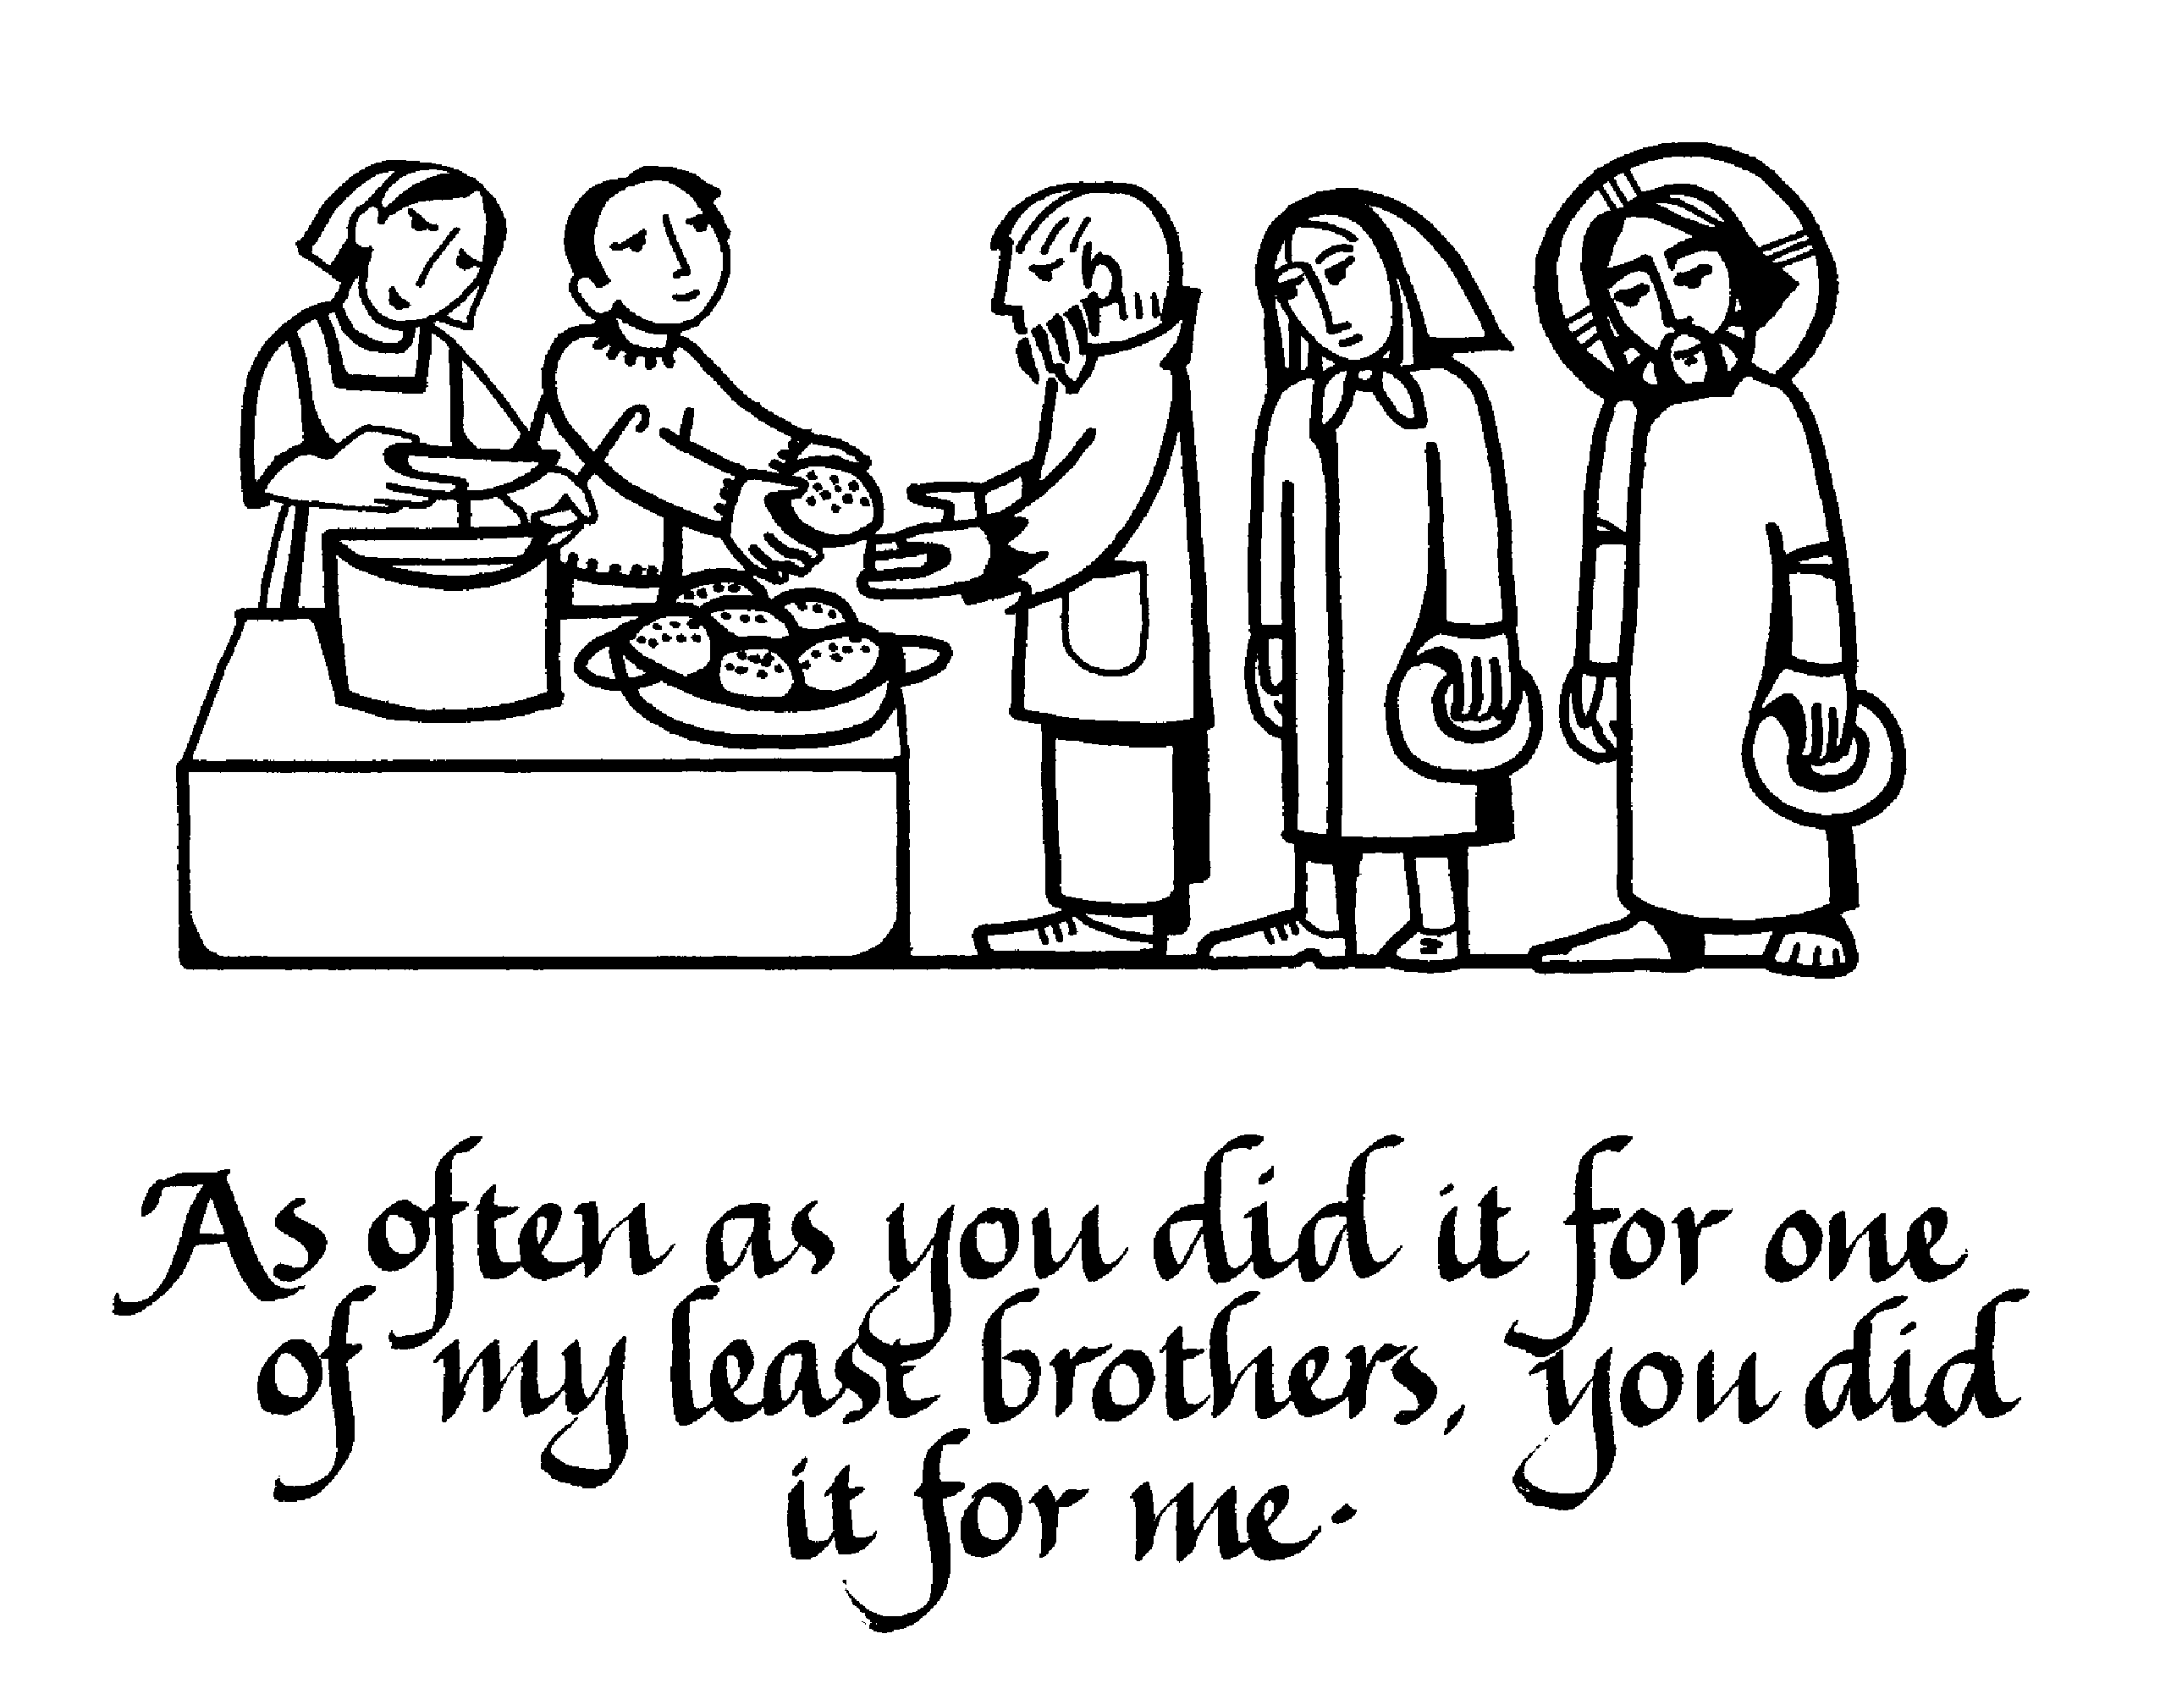
The King will reply, 'Truly I tell you, whatever you did for one of the least of these brothers and sisters of mine, you did for me.' "Then he will say to those on his left, 'Depart from me, you who are cursed, into the eternal fire prepared for the devil and his angels. For I was hungry and you gave me nothing to eat, I was thirsty and you gave me nothing to drink, I was a stranger and you did not invite me in, I needed clothes and you did not clothe me, I was sick and in prison and you did not look after me.” They also will answer, 'Lord, when did we see you hungry or thirsty or a stranger or needing clothes or sick or in prison, and did not help you?" He will reply, 'Truly I tell you, whatever you did not do for one of the least of these, you did not do for me.' (Matthew 25: 40-45).

Parishioners who may need a “helping hand,” may contact the SVDP Society for assistance, or speak with our local SVDP representatives: Bruno George (mobile: 0470571041) at Wilson Parish, or Sister Charla (telephone: 93545083) at Riverton Parish. The names of those requesting and receiving assistance is always confidential.

