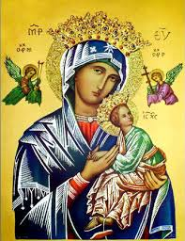
Our Lady of Perpetual Help Parish
14 Castledare Place, Wilson 6107. Telephone: 9258 6003
Email: Wilson@perthcatholic.org.au
Website: www.wilsoncatholicchurch.org
Parish Priest: Reverend Father Greg D’Almeida.
Email: gregory.dalmeida@perthcatholic.org.au
Presbytery Telephone: 9458 6586
Parish Council and Rosters: Lorraein O’Callaghan-Munt.
Mobile Number: 0417942854 Email: Munt.pandL8@bigpond.com
Parish Safeguarding Officers: Toto Olita and Rob Marshall
Parish Newsletter: Cliff Nunes. Email: cliffordgerard@bigpond.com
14th Sunday in Ordinary Time. Year C. 03rd July 2022

Gospel: Luke 10: 1-12, 17-20
The Lord appointed seventy-two others and sent them out ahead of him, in pairs, to all the towns and places he himself was to visit. He said to them, ‘The harvest is rich but the labourers are few, so ask the Lord of the harvest to send labourers to his harvest. Start off now, but remember, I am sending you out like lambs among wolves. Carry no purse, no haversack, no sandals. Salute no one on the road. ‘Whatever house you go into, let your first words be, “Peace to this house!” And if a man of peace lives there, your peace will go and rest on him; if not, it will come back to you. Stay in the same house, taking what food and drink they have to offer, for the labourer deserves his wages; do not move from house to house. ‘Whenever you go into a town where they make you welcome, eat what is set before you. Cure those in it who are sick, and say, “The kingdom of God is very near to you.” But whenever you enter a town and they do not make you welcome, go out into its streets and say, “We wipe off the very dust of your town that clings to our feet, and leave it with you. Yet be sure of this: the kingdom of God is very near.” I tell you, on that day it will not go as hard with Sodom as with that town.’ The seventy-two came back rejoicing. ‘Lord,’ they said ‘even the devils submit to us when we use your name.’ He said to them, ‘I watched Satan fall like lightning from heaven. Yes, I have given you power to tread underfoot serpents and scorpions and the whole strength of the enemy; nothing shall ever hurt you. Yet do not rejoice that the spirits submit to you; rejoice rather that your names are written in heaven.’

In Summary
At the very end of Luke’s Gospel, Jesus’ final instruction to the disciples is to proclaim the Good News to all the nations (Luke 24:47). In today’s text, it is almost as if Jesus is throwing them into the deep end! They are sent out on their first missionary assignment as raw recruits, with little to help them, but the lessons they learn here will be greatly needed later. Whatever they seek to achieve in Jesus’ name, they are given the assistance they need. Jesus, however, reminds them that the crucial factor is not that they are powerful or that they are successful. What really matters is that they are doing the will of God, in Jesus’ name, and this is the reason for their ultimate salvation. (Ref: Melbourne Archdiocese Summit – Exploring the Word).

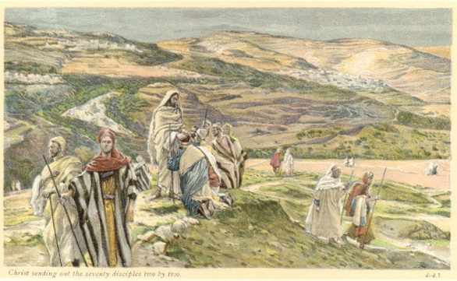
Background on the Gospel Reading
Today's Gospel follows last Sunday's Gospel when Jesus warned the disciples of the difficulties and the personal sacrifices, which will be required of His disciples on their apostolic mission (after His Death, Resurrection and Ascension to heaven), however, at this stage of Jesus’ final journey to Jerusalem; are they ready? Here Jesus appoints 72 of His followers, to go ahead of Him in pairs to every town and place He plans to visit, proclaiming that the “Kingdom of God is very near to you.” This is a “training run” for the disciples, who will eventually be Jesus’ apostles, on their mission to “spread the news of the Kingdom of God,“ to all nations, after His Ascension and Pentecost.

Jesus admits it will be difficult, and that He is sending them out “like lambs among wolves.” However, Jesus also provides guidance on how to conduct their mission:
- They are to bring nothing with them, not even a money bag or sandals.
- They are to greet no one on the way so as not to be distracted from their mission.
- When they enter a house, their message is simply: “Peace to this house.” The response they will receive may be positive or negative.
- They are not to demand special treatment but be grateful, and eat and drink, whatever is given to them.
- They are to stay in whatever accommodation offered to them and are not to look around for one that provides better lodgings.
- They are to heal the sick as a sign that the Kingdom of God is at hand.
- If the town will not receive them, they are to shake the dust from their feet and move on.

When they returned from their mission, they were elated because their mission had been successful – even demons were under their power because of Jesus' name. What today's and last Sunday's Gospel reveal, is Jesus (like a good leader and teacher) is preparing His disciples for their apostolic mission, after His Ascension and Pentecost.

Jesus Had Scores of Disciples and the Jewish Religious Leaders Feared Him
At this stage of His ministry, Jesus had scores of disciples (today’s gospel highlights 72) and perhaps even more (at the Miracle of the Multiplication of Bread and Fish, at Galilee previously, the gospel records that a crowd of 5,000 men, plus women and children, were present). Consequently, the Jewish religious leaders viewed Jesus as a threat (later gospels will reveal that scribes and pharisees were sent, in attempts to discredit Jesus). If it was just Jesus and twelve men, visiting villages and preaching to the people, the religious leaders would have ignored Him but at this time in Jesus’ ministry, Jesus had a large following and the religious leaders felt threatened.

Many of Jesus’ Followers/Disciples were Women
Jesus had many more followers besides the twelve (who were His closest followers) as we read in today’s gospel. Followers and disciples are the same (they are those who follow the Word of Jesus Christ). When the word disciple is used in the New Testament, it is usually to distinguish the twelve from Jesus’ many other followers, both men and women:

A group of women stayed with Jesus as He was crucified, even when all the men abandoned Him: “Some women were there, watching from a distance, including Mary Magdalene, Mary (the mother of James the younger and of Joseph), and Salome. They had been followers of Jesus and had cared for him while he was in Galilee. Many other women who had come with him to Jerusalem were also there.” (Mark 15:40-42). But others are named: Joanna the wife of Chuza, and Susanna (Luke 8: 1-3), and then there are Martha and Mary of Bethany (the sisters of Lazarus). So, there were also female disciples of Jesus during His ministry.
We are disciples of Jesus.

Our Parish Worship Schedule
A parish is a community of disciples of Jesus, who gather to celebrate the Mass and to “live the Gospel.” We are a community of Jesus’ disciples and our church is here for our collective and individual worship and prayers. We welcome the faithful to our Mass, or, to light a candle at our Marian chapel, or, to just pray in silence; and to grow spiritually.

Mass Times Mon, Tue, Wed, Thu & Fri 8.00 am (the Rosary after)
Saturday 6.00 pm
Mass Times Sunday 9.30 am
Reconciliation Saturday night 5.15 – 5.45 pm
Anointing of the Sick Liaise with Fr Greg
Baptisms, marriages and funerals Liaise with Fr Greg

Our Prayers of the Faithful
In our parish prayers of the faithful, we pray to the Lord, to help and comfort our sick and suffering. We also pray for the souls of our recently departed, as well as, for those whose anniversaries, we remember at Mass today.

Prayers for Our Sick and Suffering
Maria Marshall, Claire Webster, Ivan Fletcher, Fabian Edmunds, Celia, Crowley family, Joe Sundaram, Thilak, Diana Scully, Bluey Thompson, Celeste Vicensoni, Carla, Annette, Joe Gibson, Georgina and Ronnie Ghosh, Gemma Altieri, Fred Kara, Reg Brown, Mary & Derrick Jansen, Marie Webster Viola, Gerry and Maisie Prendergast, James Rydqvist, Annie Magdalena Rydqvist, Anne Rydqvist, Dr Andrew Chilufya Snr, Robbie Iliffe, Donna Green, Horatio Hill, Ilean Wright, Cathy and Peter Ghouse, Jimmy Olivero, Kaye McIntyre, Jeff and Tony Francis, Fr Andre, Sheila Vanwieringan, CD Joseph, Marina Lim, Wendy Price, Julie Pinto, Christopher Jaffer, Yianni Donato, Bonnie Sullivan, Joslyn De Sylva and Philomena Rodrigues.

Prayers for our Recently Departed
John Cova, Phyllis Falk, Gopi Panickar, Sandra Young, Matthew Antony and Annamma Antony.
“God blesses those people who grieve. They will find comfort.” (Matthew 5:4).

Anniversaries of our Beloved Departed
Ted Stephenson (30 Jun), John Heng (30 Jun), Nodio Ballestas (01 Jul), Kenneth Singh (03 Jul), Josephine Madrigal (03 Jul), Rita Meneses (06 Jul) and all our departed relatives and friends.
Jesus assured Martha at the tomb of Lazarus: “I am the Resurrection and the life; whoever believes in Me will live even though he dies” (John 11: 25-26).

Note: Parishioners may email Cliff at: cliffordgerard@bigpond.com, for any additions (or deletions) to our lists of sick, recently deceased and anniversaries, whom you wish to be included in our “Prayers of the Faithful.” Thank-you.
Everyone has a name, and if we are to pray for them, we should say their name.

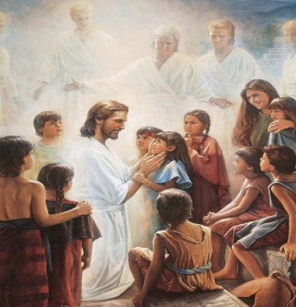
We Welcome “God’s Little Children” to Our Mass
People were bringing little children to Jesus to have him touch them, but the disciples rebuked them. When Jesus saw this, he was indignant. He said to them, “Let the little children come to me, and do not hinder them, for the kingdom of God belongs to such as these.” Mk 10: 13-14.

Activity sheets and colour pencils, are available at the rear of the church, to occupy the children during Mass. Parents may even pin their child’s work on the noticeboard (when space is available) for others to appreciate their efforts.

This Weekend is Our Parish St Vincent de Paul (SVDP) Donations

Food donations may be left at the rear of the church (a box is situated for small items/donations), or, in the parish centre. Cash donations may be deposited in the poor box at the door. Every donation helps SVDP to help the needy in our local communities.

Parishioners who may need a “helping hand,” may contact the SVDP Society for assistance, or speak with our local SVDP representatives: Bruno George (mobile: 0470571041) at Wilson Parish, or Sister Charla (telephone: 93545083) at Riverton Parish. The names of those requesting and receiving assistance is always confidential.

Copies of the Archdiocese Magazine – The Record
Copies of The Record are available at the rear of the church for parishioners. Not just with archdiocese news but also, interesting articles on various subjects.

