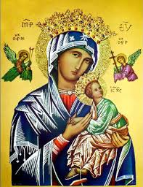
Our Lady of Perpetual Help Parish
14 Castledare Place, Wilson 6107. Telephone: 9258 6003
Email: Wilson@perthcatholic.org.au
Website: www.wilsoncatholicchurch.org
Parish Priest: Reverend Father Greg D’Almeida.
Email: gregory.dalmeida@perthcatholic.org.au
Presbytery Telephone: 9458 6586
Parish Council and Rosters: Lorraein O’Callaghan-Munt.
Mobile Number: 0417942854 Email: Munt.pandL8@bigpond.com
Parish Safeguarding Officers: Toto Olita and Rob Marshall
Parish Newsletter: Cliff Nunes. Email: cliffordgerard@bigpond.com
15th Sunday in Ordinary Time. Year C. 10th July 2022

Gospel: Luke 10: 25-37
There was a lawyer who, to disconcert Jesus, stood up and said to him, ‘Master, what must I do to inherit eternal life?’ He said to him, ‘What is written in the Law? What do you read there?’ He replied, ‘You must love the Lord your God with all your heart, with all your soul, with all your strength, and with all your mind, and your neighbour as yourself.’ ‘You have answered right,’ said Jesus ‘do this and life is yours.’
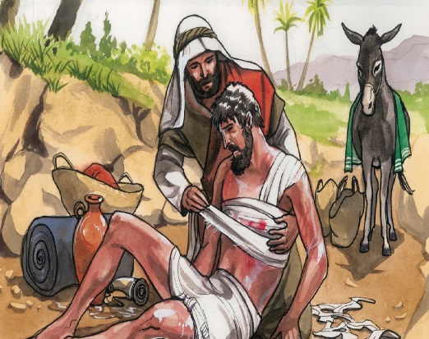
But the man was anxious to justify himself and said to Jesus, ‘And who is my neighbour?’ Jesus replied, ‘A man was once on his way down from Jerusalem to Jericho and fell into the hands of brigands; they took all he had, beat him and then made off, leaving him half dead. Now a priest happened to be travelling down the same road, but when he saw the man, he passed by on the other side. In the same way a Levite who came to the place saw him, and passed by on the other side. But a Samaritan traveller who came upon him was moved with compassion when he saw him. He went up and bandaged his wounds, pouring oil and wine on them. He then lifted him on to his own mount, carried him to the inn and looked after him. Next day, he took out two denarii and handed them to the innkeeper. “Look after him,” he said “and on my way back I will make good any extra expense you have.” Which of these three, do you think, proved himself a neighbour to the man who fell into the brigands’ hands?’ ‘The one who took pity on him’ he replied. Jesus said to him, ‘Go, and do the same yourself.’

In Summary
The parables that Jesus tells were always designed to shock those listening. To our modern ears, the shock lies in the fact that the priest and Levite simply walked past the wounded man, but this would not have been a shock to those of Jesus’ time. These men had sacred duties to perform in the temple. If the man was dead or even bleeding and they came into contact with him, they would not have been able to perform their obligations to God! The real shock to those listening in Jesus’ day lies in the response of the Samaritan. Between Jews and Samaritans, there was enmity and suspicion that went back centuries. Samaritans do not behave like that! To be so moved by compassion for the wounded man that he bathes and dresses the wounds and pays for his further care would seem outrageous to the Jews. This practical application of ‘love of neighbour’ is taken a step further when Jesus commands that the lawyer act in the same way as the Samaritan. This too would have been a shock!
(Ref: Melbourne Archdiocese Summit – Exploring the Word).

There is a timelessness in this parable. The image of the injured man calls us to show compassion and to come to the aid of others.

In Conclusion
Jesus uses the parable of the Good Samaritan to explain “being a good neighbour.”
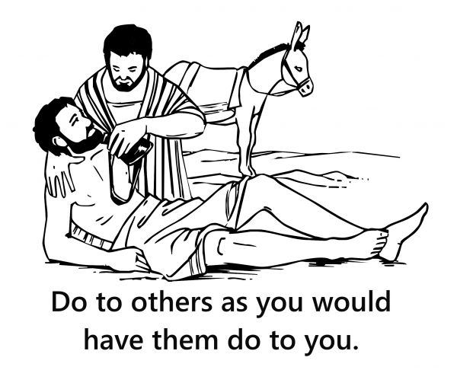
Jesus does not identify who the victim is, however, He identifies the “good neighbour,” as a Samaritan (Samaritans were hated by the Jews because they were descendants of Jews from the northern part of the country, who had intermarried with Gentiles and did not worship in Jerusalem). Yet, it is the Samaritan who helps the victim; he cleans the man’s wounds, puts him on his own animal, takes him to an inn to recover, and promises to pay all his expenses. The hated enemy is the compassionate/good neighbour in this parable.

Jesus chose a Samaritan in this parable, to reveal that a neighbour is not determined by class, religion, ethnicity, or, nationality. A good neighbour is a person who acts with compassion towards others, regardless of who that person is. Jesus wants us to treat everyone with compassion and generosity - we know what is right, we just have to do it.

Our Parish Worship Schedule
A parish is a community of disciples of Jesus, who gather to celebrate the Mass and to “live the Gospel.” We are a community of Jesus’ disciples and our church is here for our collective and individual worship and prayers. We welcome the faithful to our Mass, or, to light a candle at our Marian chapel, or, to just pray in silence; and to grow spiritually.
Mass Times Mon, Tue, Wed, Thu & Fri 8.00 am (the Rosary after)
Saturday 6.00 pm
Mass Times Sunday 9.30 am
Reconciliation Saturday night 5.15 – 5.45 pm
Anointing of the Sick Liaise with Fr Greg
Baptisms, marriages and funerals Liaise with Fr Greg

Our Prayers of the Faithful
In our parish prayers of the faithful, we pray to the Lord, to help and comfort our sick and suffering. We also pray for the souls of our recently departed, as well as, for those whose anniversaries, we remember at Mass today.

Prayers for Our Sick and Suffering
Maria Marshall, Claire Webster, Ivan Fletcher, Fabian Edmunds, Celia, Crowley family, Joe Sundaram, Thilak, Diana Scully, Bluey Thompson, Celeste Vicensoni, Carla, Annette, Joe Gibson, Georgina and Ronnie Ghosh, Gemma Altieri, Fred Kara, Reg Brown, Mary & Derrick Jansen, Marie Webster Viola, Gerry and Maisie Prendergast, James Rydqvist, Annie Magdalena Rydqvist, Anne Rydqvist, Dr Andrew Chilufya Snr, Robbie Iliffe, Donna Green, Horatio Hill, Ilean Wright, Cathy and Peter Ghouse, Jimmy Olivero, Kaye McIntyre, Jeff and Tony Francis, Fr Andre, Sheila Vanwieringan, CD Joseph, Marina Lim, Wendy Price, Julie Pinto, Christopher Jaffer, Yianni Donato, Bonnie Sullivan, Joslyn De Sylva and Philomena Rodrigues.

Prayers for our Recently Departed
John Cova, Phyllis Falk, Gopi Panickar and Sandra Young.
“God blesses those people who grieve. They will find comfort.” (Matthew 5:4).

Anniversaries of our Beloved Departe;
Brenda Hendriks (07 Jul), Marie Travers (07 Jul), Ellen Mulcahy (08 Jul), George Vanwieringan (09 Jul), Ivy Bond (10 Jul), Maire Yee (10 Jul), Terence O’Connor (11 Jul), Fed Boswell (11 Jul), Louis Matthews (12 Jul) and all our departed relatives and friends.
Jesus assured Martha at the tomb of Lazarus: “I am the Resurrection and the life; whoever believes in Me will live even though he dies” (John 11: 25-26).

Note: Parishioners may email Cliff at: cliffordgerard@bigpond.com, for any additions (or deletions) to our lists of sick, recently deceased and anniversaries, whom you wish to be included in our “Prayers of the Faithful.” Thank-you.
Everyone has a name, and if we are to pray for them, we should say their name.

We Welcome “God’s Little Children” to Our Mass
People were bringing little children to Jesus to have him touch them, but the disciples rebuked them. When Jesus saw this, he was indignant. He said to them, “Let the little children come to me, and do not hinder them, for the kingdom of God belongs to such as these.” Mk 10: 13-14.

Activity sheets and colour pencils, are available at the rear of the church, to occupy the children during Mass. Parents may even pin their child’s work on the noticeboard (when space is available) for others to appreciate their efforts.
For All Our Parish Volunteers – Both Seen and Unseen

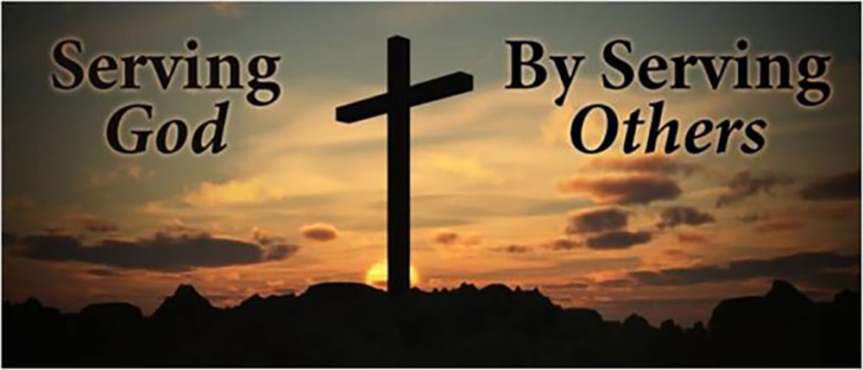
“If anyone serves me, the Father will honour him” John 12:26

We thank our wonderful parishioners who serve God in our many parish ministries. Some are “seen,” but many we do not see; yet they all serve the Lord (and indirectly - all of us) by using their “talents” and giving their time, in their respective church ministries. Some of these ministries are seen, like: the acolytes, the lectors and our music ministry; but many are unseen, like: our parish council, our church housekeepers, our collection counters, our floral ministers, those who prepare our Prayers of the Faithful, and the silent individuals who tend to our parish garden, as well as, repairs and maintenance to our church, or, avail themselves for any parish task and responsibility (like our Parish Safeguarding officers).

Our Collective Thanks and Appreciation to you
Because you serve the Lord in His Church through the faithful exercise of your “talents” and time, you have also enriched us and our parish. For your faithfulness and devotion, we thank you and pray that God will bless you for your good works.

Note: We welcome everyone who wishes to serve God in our parish ministries - there will always be a place for you. Just speak with any of our parish volunteers. Thanks, Cliff.

Monday 11th July is the Feast Day of St Benedict
St Benedict was a monk who started the early Christian monasteries in the sixth Century. These Benedictine monasteries spread over Europe to become centres of learning, agriculture, hospitality, and medicine. St Benedict probably died in 547.

Meanwhile in Western Australia
New Norcia is Australia’s only monastic town and a Benedictine Community, 132 km North of Perth. Founded in 1847 by Spanish Benedictine Monks.

